**[28] Design DFA Which Accepts String Ends With ‘AB’ And Accepts ABBAABAB**

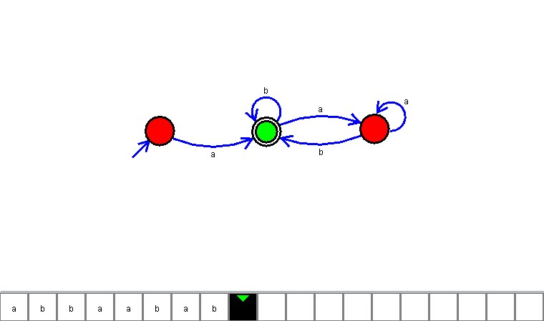

**Result**

The DFA is designed to compute the strings as input using Automaton Simulator